**Lab 7: ADC and UART serial communication**

* Table with voltage divider, calculated, and measured ADC values for all buttons.

|  |
| --- |
|  |
| **Push button** | **PC0[A0] voltage** | **ADC value (calculated)** |
| Right | 0 V | 0 |
| Up | 0.495 V | 101 |
| Down | 1,20 V | 245 |
| Left | 1,97 V | 403 |
| Select | 3,17 V | 648 |
| none | 5 V | 1023 |

* Listing of ADC_vect interrupt routine with complete code for sending data to the LCD/UART and identification of the pressed button.

ISR(ADC_vect)

{

// WRITE YOUR CODE HERE

*uint16_t* value = 0;

char lcd_string[4] = "0000";

value = ADC; // Copy ADC result to 16-bit variable

*itoa*(value, lcd_string, 10); // Convert decimal value to string

lcd_clrscr();

lcd_gotoxy(1, 0); lcd_puts("value:");

lcd_gotoxy(3, 1); lcd_puts("key:");

if(value == 1022){

lcd_gotoxy(8, 0); lcd_puts(lcd_string); // Put ADC value in decimal

lcd_gotoxy(13,0); lcd_puts("3FE"); // Put ADC value in hexadecimal

lcd_gotoxy(8, 1); lcd_puts("none "); // Put button name here

uart_puts("none");

}else if(value == 650){

lcd_gotoxy(8, 0); lcd_puts(lcd_string) // Put ADC value in decimal

lcd_gotoxy(13,0); lcd_puts("28A");// Put ADC value in hexadecimal

lcd_gotoxy(8, 1); lcd_puts("Select ");// Put button name here

uart_puts("Select");

}else if(value == 402){

lcd_gotoxy(8, 0); lcd_puts(lcd_string); // Put ADC value in decimal

lcd_gotoxy(13,0); lcd_puts("192"); // Put ADC value in hexadecimal

lcd_gotoxy(8, 1); lcd_puts("Left "); // Put button name here

uart_puts("Left");

}else if(value == 245){

lcd_gotoxy(8, 0); lcd_puts(lcd_string); // Put ADC value in decimal

lcd_gotoxy(13,0); lcd_puts("F5"); // Put ADC value in hexadecimal

lcd_gotoxy(8, 1); lcd_puts("Down "); // Put button name here

uart_puts("Down");

}else if(value == 101){

lcd_gotoxy(8, 0); lcd_puts(lcd_string); // Put ADC value in decimal

lcd_gotoxy(13,0); lcd_puts("65"); // Put ADC value in hexadecimal

lcd_gotoxy(8, 1); lcd_puts("Up "); // Put button name here

uart_puts("Up");

}else{

lcd_gotoxy(8, 0); lcd_puts(lcd_string); // Put ADC value in decimal

lcd_gotoxy(13,0); lcd_puts("00"); // Put ADC value in hexadecimal

lcd_gotoxy(8, 1); lcd_puts("Right "); // Put button name here

uart_puts("Right");

}

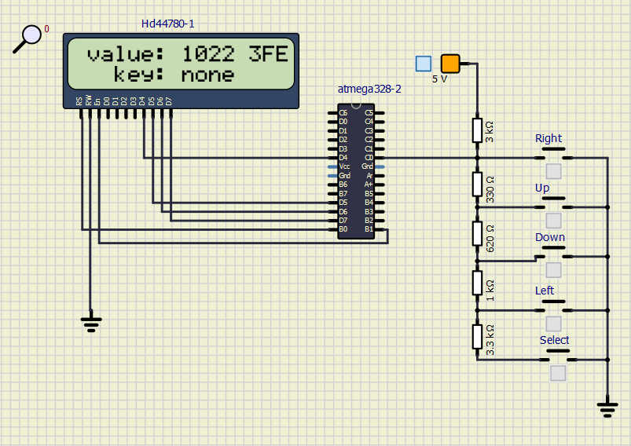}

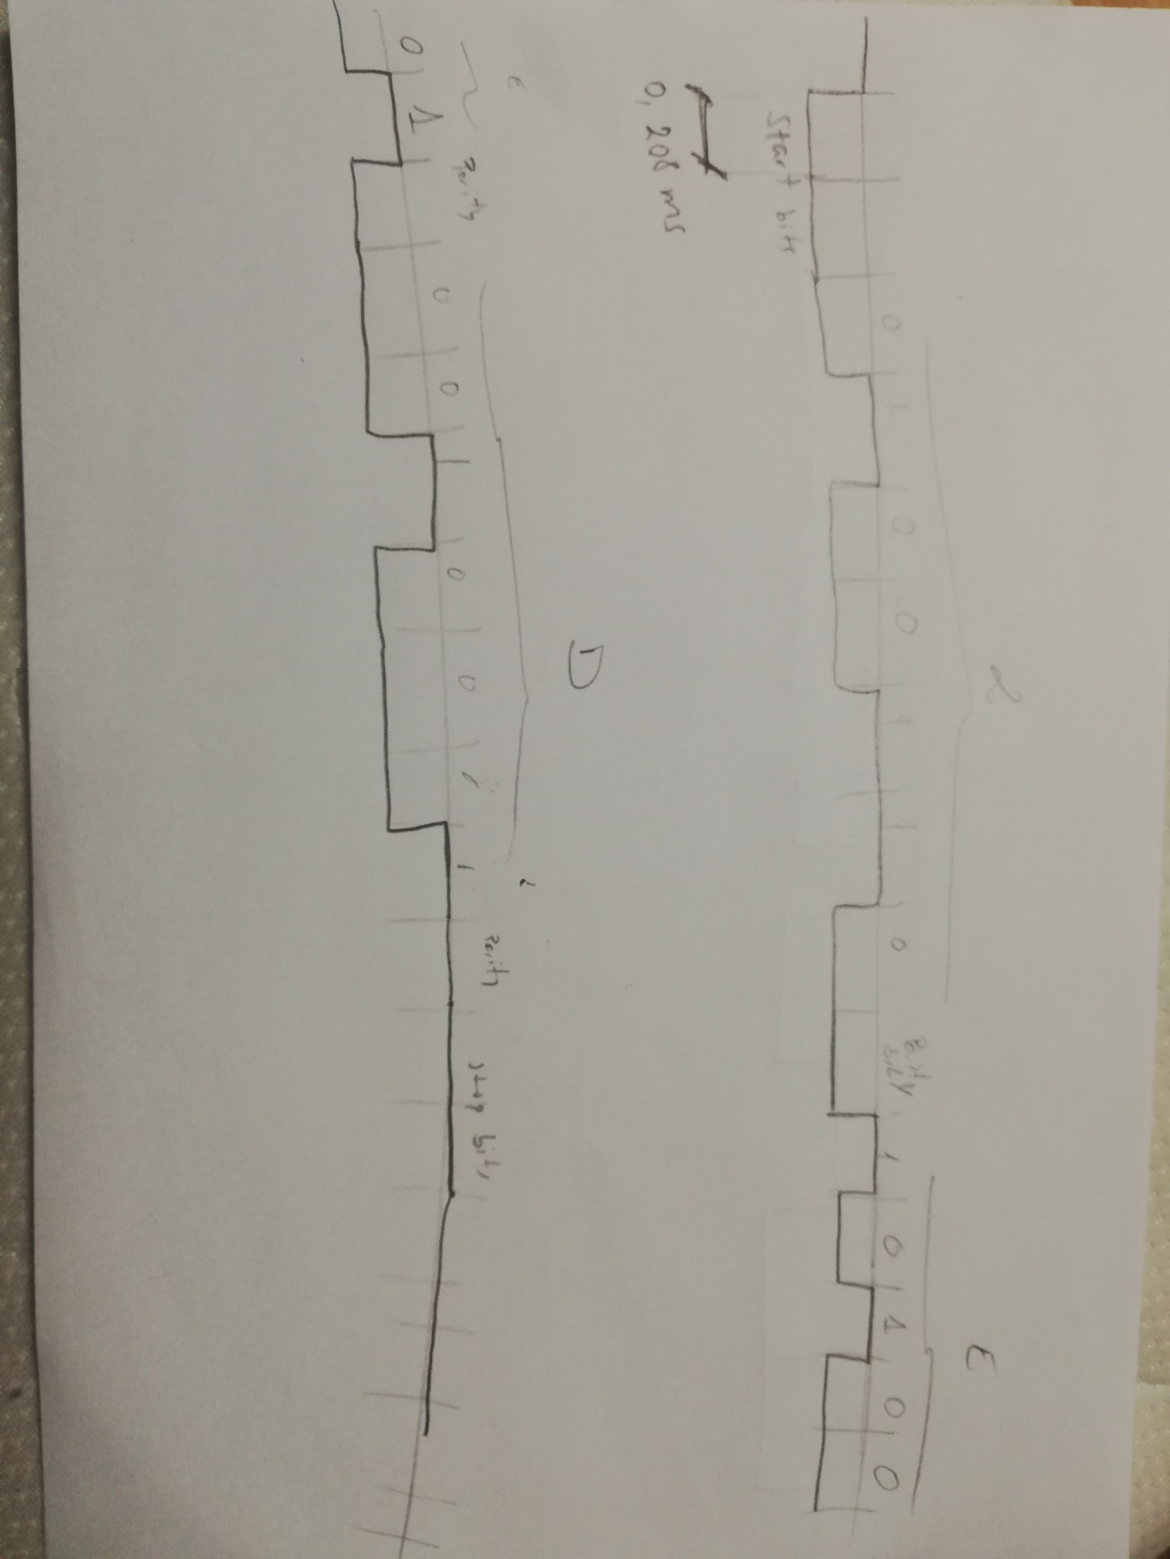

* (Hand-drawn) picture of UART signal when transmitting data DE2 in 4800 7O2 mode (7 data bits, odd parity, 2 stop bits, 4800 Bd)
* Listing of code for calculating/displaying parity bit.

*uint8_t* c;

*uint8_t* inc;

*uint8_t* par = 0;

char lcd_string[1] = "0";

c = uart_getc();

if (c != '\0') { // Data available from UART

if (c == '1') { // Key '1' received

inc++;

}

}

if(inc%2 == 0){

par = 1;

}else{

par = 0;

}

*itoa*(par, lcd_string, 10);

lcd_gotoxy(8, 0); lcd_puts(lcd_string);